**Login/ Registration form using Figma**

Description:

The displayed design is created using Figma, a powerful web-based design tool. It features a login and registration form with a modern and clean aesthetic, incorporating reusable components like buttons and input fields. The design allows users to switch between login and registration. The use of Figma allows for easy prototyping, collaboration, and customization of the forms for a responsive and user-friendly interface.

Fig 1:



Fig 2:

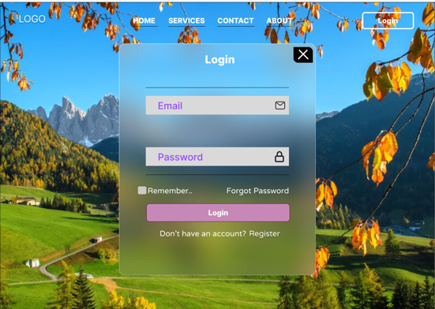

Fig 3:

